
Open Education

No. 78 July 20, 2019
We shouldn’t treat teachers as interchangeable widgets on a production line - Anon

STDENT ACHIEVEMENT LEVELS
A teacher’s role is to help another person learn. As part of the teaching process, teachers need to gather information about what a student already knows, what the student needs/wants to know and be able to do, and obstacles blocking progress. The process of diagnosing may include gathering information from the student as well as from others. Testing students to better understand what to do next is part of the teaching-learning process.

As I understand it, the difference between any two people in terms of their level of achievement depends on the skills learned, levels achieved on those skills and the particular applications or clustering of skills and competencies

It seems a bit incestuous, however for the Department Education to require attendance, determine what will be taught, train and employ teachers to teach it, determine achievement levels and who qualifies for each level. Teachers certainly must be familiar with standards in their subject but they shouldn’t be the one to set and aaward themset them.

LEADERSHIP CHANGE

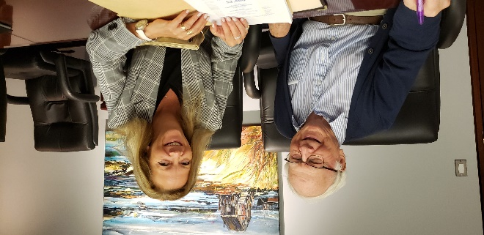
Sharon Cameron, President of Education 20/20 Inc. and Don Glendenning, Past President, discuss the agenda for an upcoming Executive meeting

EDUCATION EXPERTISE
The Sydney Morning Herald reports that Australia plans to export its “HSC and VCE” ( High School Certificate and Victorian Certificate of Education) to the “lucrative international school market.”

SACKVILLE SCHOOLS 20/20
ou may have noticed that “Sackville Schools 2020” has transitioned to the more official “Sackville 20/20”—a registered non-profit. The 20/20 represents “clear seeing and a strong vision for community supported education”

Don Glendenning, Editor
_______________________________________
Education 20/20 Inc.
PO Box 624 / 101, rue Kent, B.P. 624
Charlottetown, PEI / C1A 1M0
Email/Courriel : pei@education2020.ca URL : www.education2020.ca

